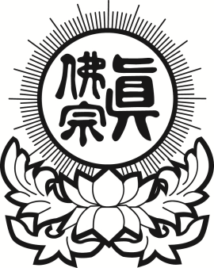
真佛宗紐約金剛雷藏寺
True Buddha Diamond Temple of NY
33-32 148th Street, Flushing, NY 11354
Tel: (718) 888-7919 Fax: (718) 888-1966
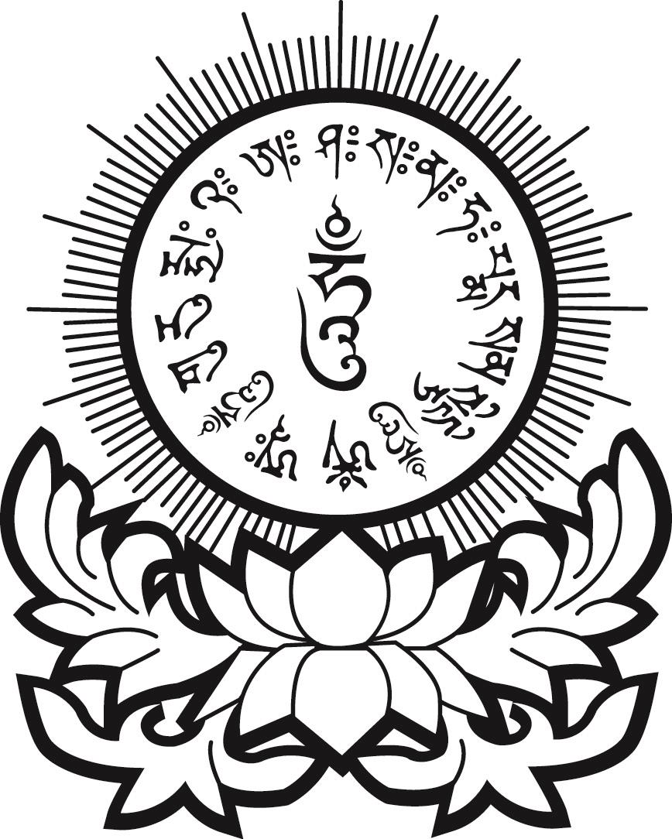

7/3/2016
無極瑤池金母如意超度功德主
USD$138

Deceased name: 亡者(或靈界眾生)：
Resting place: 安靈地址:

